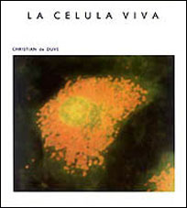

https://www.youtube.com/watch?v=5GATtn4edeU

