Name: Date:

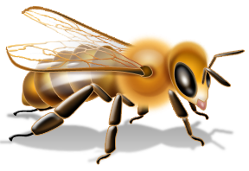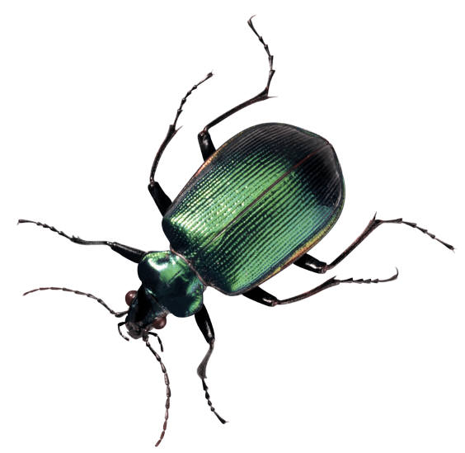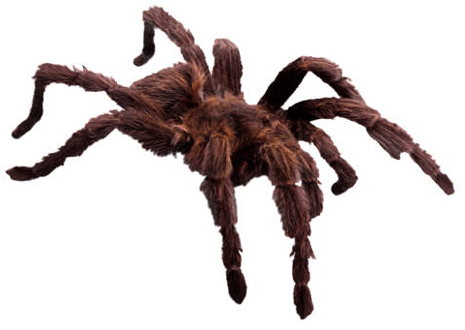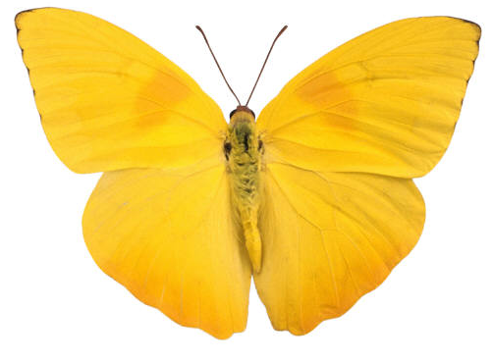
Zein galdera gehiago egingo zenuke? Nola ebaluatuko zenuke alderdi hau: gorputzaren egitura, funtzioak (mugimendua, ugalketa, babesa,..) eta eskuratzen duen energía eta haien arteko erlazioak?

- My minibeast is called:

- My minibeast’s habitat is (where it lives):

It is suited to this habitat because:

- This is how my minibeast moves:

This way of moving helps my minibeast because:

Name: Date:

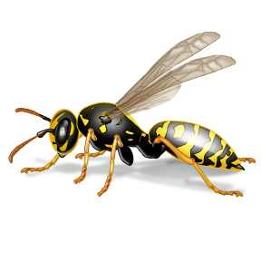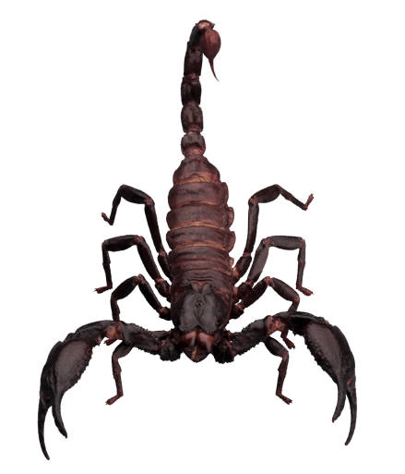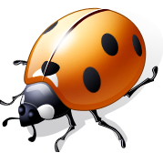

- This is what my minibeast eats:

My minibeast eats these because:

- My minibeast avoids predators by:

This is easy for it because:

- Other creatures that eat my minibeast are:

